Loading data from Excel sheet to database
This document is connected to Excel sheet “Example to load.xlsx” to be found in same directory.
- Fill the excel Sheet:

- Copy paste the data in the first tbl_person section to the tbl_person.csv and store it in another directory, do not forget to leave first column empty
- Store a number in the first column, higher than highest number in database for this field
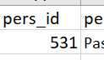
- Extract next part of Excel sheet for tbl_residence into tbl_residence.csv leave again last id column empty, store it into same directory as before
- Fill the id number column as before with same number
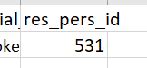
- Extract next part of Excel sheet for tbl_elc_struc1 and fill it to tbl_elc_struc1.csv leave the id column empty


- Fill the id number column as before with same number, do not forge to store it same new directory not to corrupt template
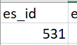
- Extract next part of Excel sheet for tbl_residence and fill it to tbl_residence.csv leave the id column empty
- Fill the id number column as before with same number
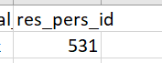
- Extract next part of Excel sheet for tbl_banking and fill it to tbl_banking.csv leave the id column empty

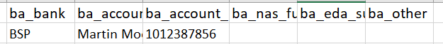
- Fill the id number column as before with same number
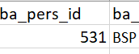
- Extract next part of Excel sheet for tbl_emergency_contact and fill it to tbl_emergency_contact.csv leave the id column empty
- Fill the id number column as before with same number
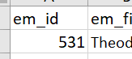
- Extract next part of Excel sheet for tbl_spouse and fill it to tbl_spouse.csv leave the id column empty

